Press note: National launch of the Aadhaar project
On 29th September 2010, Ranjna Sadashiv Sonwane, a tribal woman from Tembhali village in Nandurbar, Maharashtra, became the first recipient of the Aadhaar number. Ranjna received the Aadhaar letter from Prime Minister Manmohan Singh, on the day he launched the initiative nationally.
Ranjna’s letter marks the point where the Aadhaar initiative transforms from a technology concept to an on the ground reality. Ranjna had enrolled with her five year old son Hitesh, who was the second person to receive the Aadhaar letter. For Hitesh, Aadhaar will be his first proof of identity.
The launch of Aadhaar in Tembhali village was attended by both the Prime Minister and the UPA Chairperson, Sonia Gandhi. During a public function marking the launch, the Prime Minister acknowledged the significance of the number and dedicated Aadhaar to the service of the nation.
UPA Chairperson Smt. Sonia Gandhi also addressed the gathering, emphasizing the importance of this project in the context of the country’s increasingly mobile population and in fulfilling the government’s commitment to inclusive growth. She also recalled the vision of late Prime Minister Rajiv Gandhi, of using technology to improve the lives of the ‘aam admi’.
Chief Minister of Maharashtra, Shri. Ashok Chavan, reiterated the commitment from the State government to implement the project in a time bound manner. He pointed out the wide number of government schemes such as MGNREGS, PDS, health insurance etc that this number would be a part of and how this would enable greater financial inclusion.
Chairman of Unique Identification Authority of India (UIDAI), Shri. Nandan Nilekani, mentioned the significance of the Aadhaar number for the millions of residents who still do not have any form of identification. “Today many people in this country do not possess any form of identification. The Aadhaar number will be able to fill this void.”
The other dignitaries at the launch included Governor of Maharashtra K. Sankaranarayanan, Deputy Chairman Planning Commission Montek Singh Ahluwalia, Deputy Chief Minister of Maharashtra Chhagan Bhujbal among others.
Ranjna and Hitesh were among ten people who received letters containing their Aadhaar number from the Prime Minister and UPA Chairperson. Appendix B contains details of the residents who received the number.
Aadhaar’s focus is on the marginalized
The launch of Aadhaar from Tembhali village (see Appendix A for profile ) signifies a core vision of the initiative. The UIDAI has long emphasized that the focus of the Aadhaar number is on giving the poor and marginalized in India their first clear, easily verifiable, mobile identity. The small, largely tribal village of Tembhali is in one of Maharashtra’s most remote districts. Many residents here migrate seasonally to Gujarat as well as to Mumbai for work to supplement their incomes. The residents of Tembhali are the people that the Aadhaar number hopes to benefit the most.
The Prime Minister and the UPA Chairperson also visited the Aadhaar enrolment centre at Tembhali to see the Aadhaar enrolment and authentication of the residents.
Hopes for India’s first mobile identification
The Aadhaar number acknowledges today’s reality: that opportunities and jobs, especially for India’s poor, are changeable and often located outside the hometown and village. Many people therefore need to migrate in search of more income, and a better life. The Aadhaar number gives the Indian people their first mobile identification, which they can use anywhere in the country, with any agency, to prove their identity. “I will be able to use the number from my gully, all the way to Dilli,” Raju Makkan Madi, a resident of Tembhali, said.
“Providing greater access to people who are now marginalized and powerless”, Nandan Nilekani, Chairman of the UIDAI said, “is part of Aadhaar’s purpose.
India’s first ‘Aadhaar-gram’: the first of several milestones
Tembhali village is India’s first Aadhaar-gram – the first region in the country to have enrolled all its residents for the Aadhaar number.
For the UIDAI, the launch of Aadhaar represents the culmination of a year-long effort, in building the project’s infrastructure and systems. “We have launched the Aadhaar number on time nation-wide, keeping our promise to begin enrolling residents within 12-18 months of the start of the initiative,” Ram Sewak Sharma, Director General of the UIDAI, commented.
From the outset of the project, the UIDAI team has faced a highly demanding timeline in bringing the Aadhaar number to residents across the country. The milestone it has achieved on 29th September – the national launch of Aadhaar – is the first of several ambitious targets.

Appendix A: Profile of Tembhali village
Nandurbar is a largely rural district in northern Maharashtra, bordering Gujarat and Madhya Pradesh. It has a population of 13.1 lakh (2001 Census) and is predominantly tribal. Nandurbar was part of the larger Dhule district until 1998, after which it was carved out into a separate district. The literacy rate for men is 55.1% and women is 37.9%. The district comprises 6 talukas, namely Akkalkuwa, Akrani Mahal, Taloda, Shahada, Nandurbar and Navapur. The launch event will take place in Shahada taluka, near a village called Tembhali.
Tembhali has a population of ~1500 people. The majority of residents are from the Bhil tribe and speak Bhilori. Approximately 65% of the residents do not own any land and most are daily wage labourers, on cotton and sugarcane farms. This area sees significant migration, mainly to Saurashtra and other parts of Gujarat. The village has one fair price shop, but no post office or hospital.
Tembhali is located 436km from Mumbai by road. The closest airport is Surat, 206km away. District HQ is 40km from the village.

Appendix B: Profile of ten residents who received their Aadhaar numbers
- Ranjna Sadashiv Sonwane
40, F
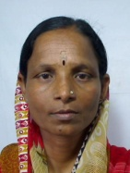

- Hitesh Sadashiv Sonwane
5, M
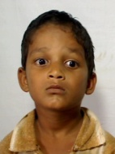

- Anil Ganesh Thakare
12, M
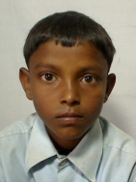

- Jalubai Shivdas Thakare
63, F
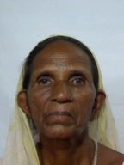

- Shiva Ratan Wagh
69, M
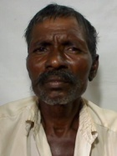

- Kantibai Nabu Nigude
65, F
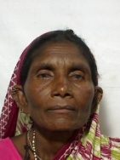

- Devidas Bhairas Mali
36, M
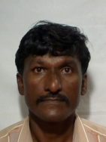

- Bhuri Rohidas Mali
20, F
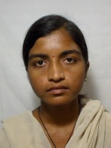

- Arman Munir Qureishi
51, M
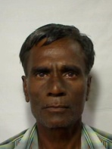

- Tarachand Padvi

